

**IT4020**

**Modern Topics in IT**

**4th Year, 1st Semester**

Assignment 2

**ENTERPRISE APPLICATION INTEGRATION (EAI)**

Submitted to

Sri Lanka Institute of Information Technology

In partial fulfillment of the requirements for the

Bachelor of Science Special Honors Degree in Information Technology

15/03/2020

|  |  |
| --- | --- |
| Student Name | Student ID |
| Rajapakshe D.D.S | IT16234062 |
| U.L.N.P. Uswatte | IT17029278 |
| Kudawithana K.N.B | IT17255820 |
| Nishshanka N.A.B.D | IT17043656 |

Contents

**1.** **Source Code:** 3

**2.** **Access API service through the Postman package** 4

**2.1 ICD API** 4

**2.2** **Facebook API** 7

**3.** **SOAP web service example in Eclipse** 12

**4.** **Access 3rd party web service through WSO2 ESB and going to test the service through ESB** 15

**5.** **SOAP UI and service implementation** 19

**6.** **WSDL services will display as below** 22

**7.** **SOAP UI project create with Student_Service_Impl.wsdl** 25

# **Source Code:**

<https://github.com/abc-instertute/SOAP-Assyment>

this service base on student registration service these screenshots are the outcome of the project. We use MVC architecture to develop java web service.

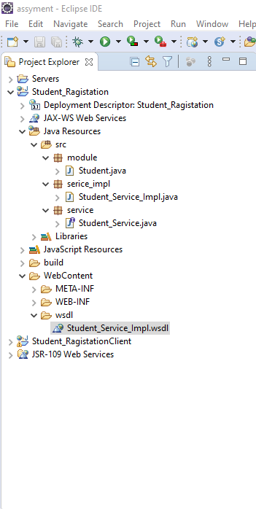

# **Access API service through the Postman package**

## **2.1 ICD API**

The API accessed site:

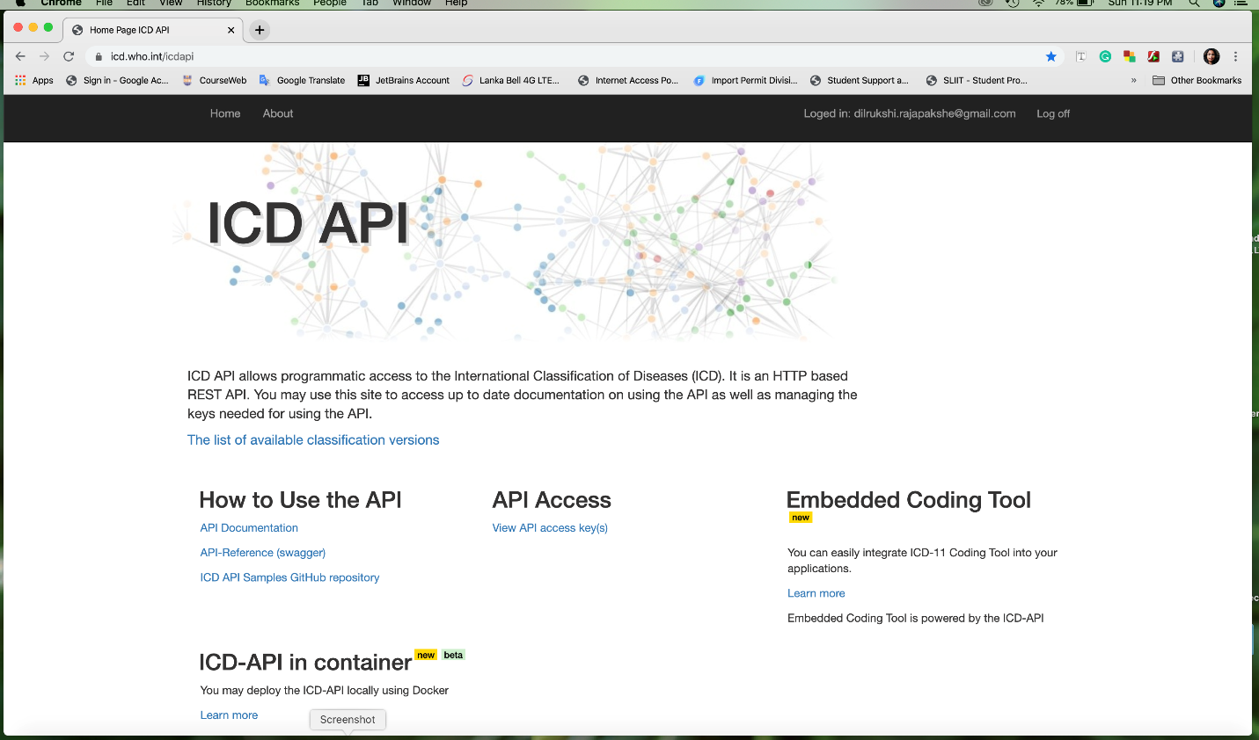

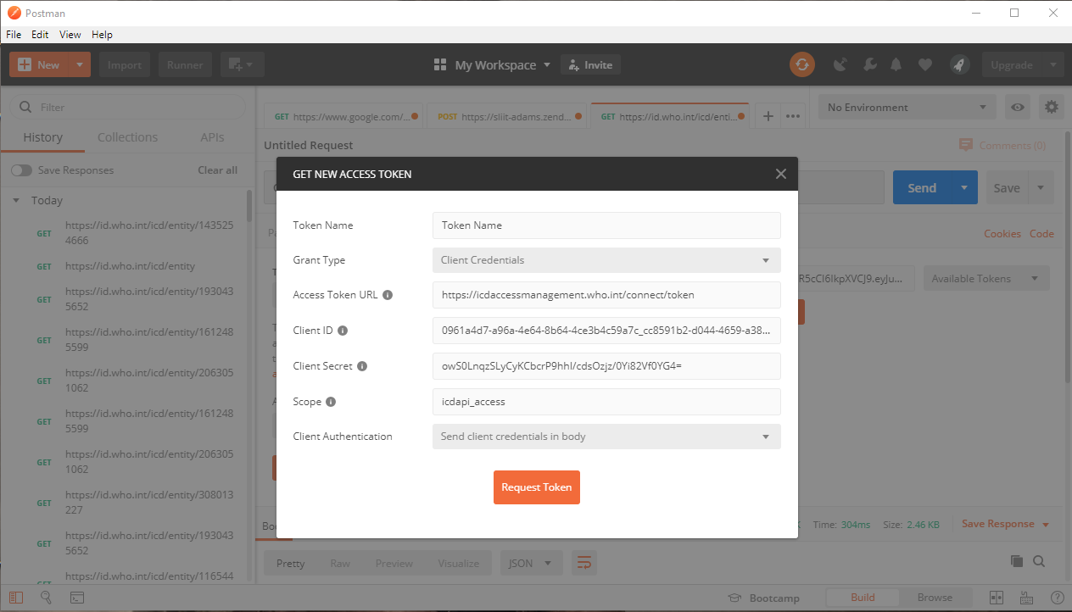Request for a new access token:

Configure the Authorization section in postman  
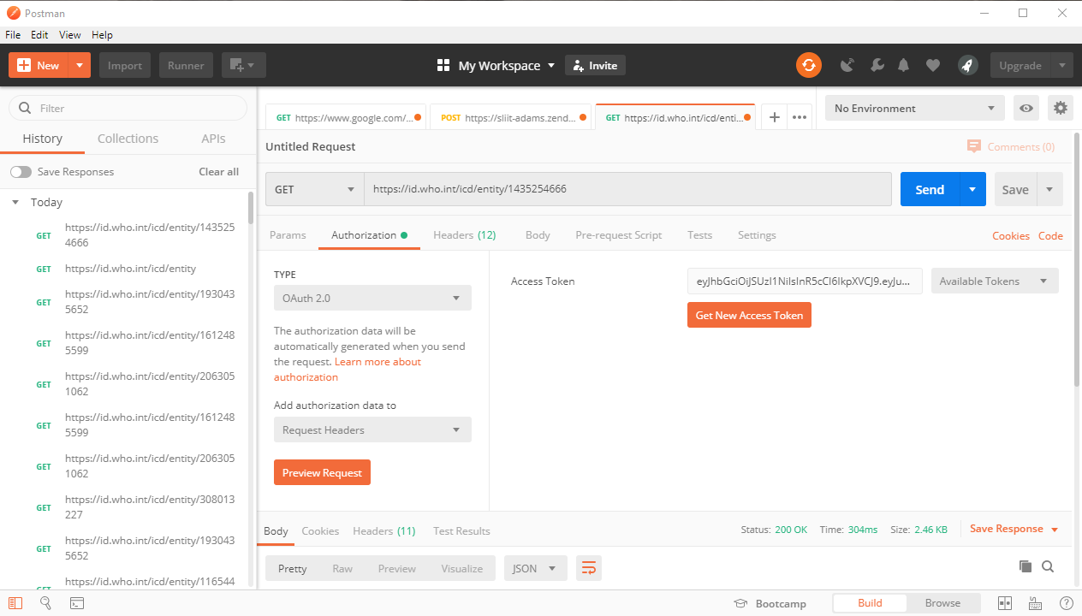

Configure the Header section by entering Keys and Values

Send the GET request and also can see the relevent response body with 200 OK

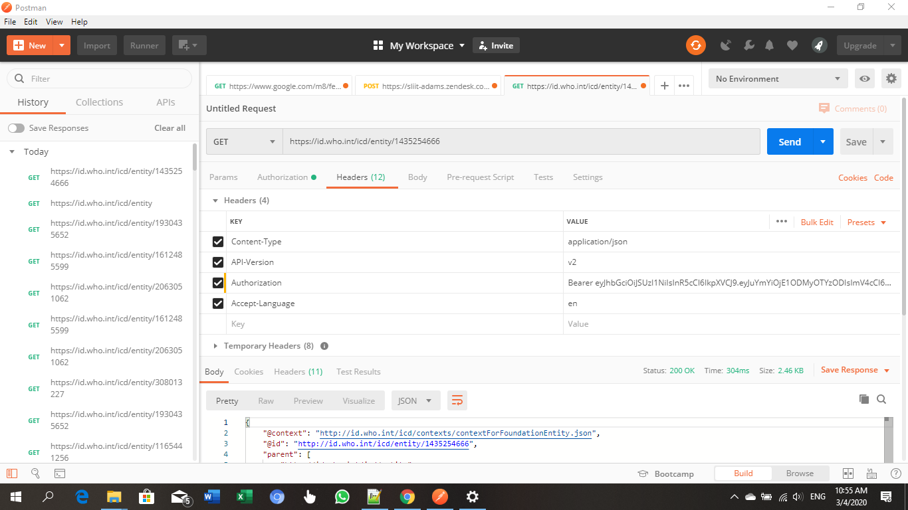

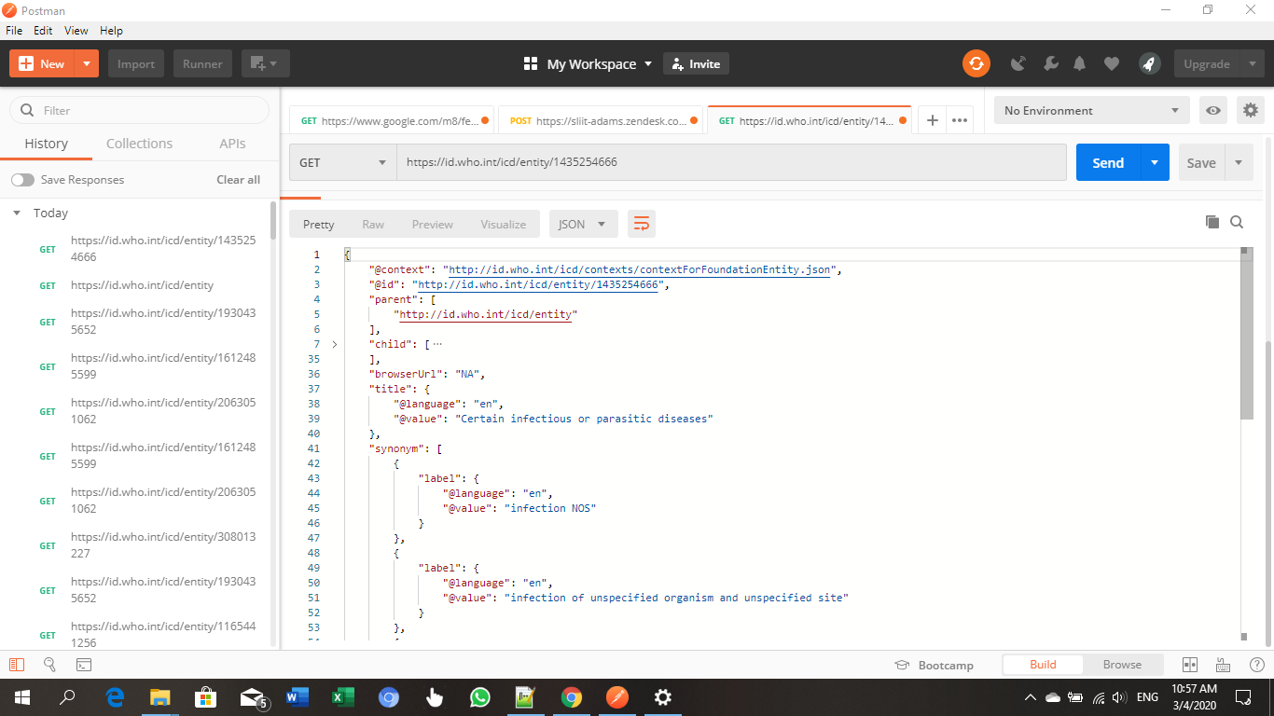

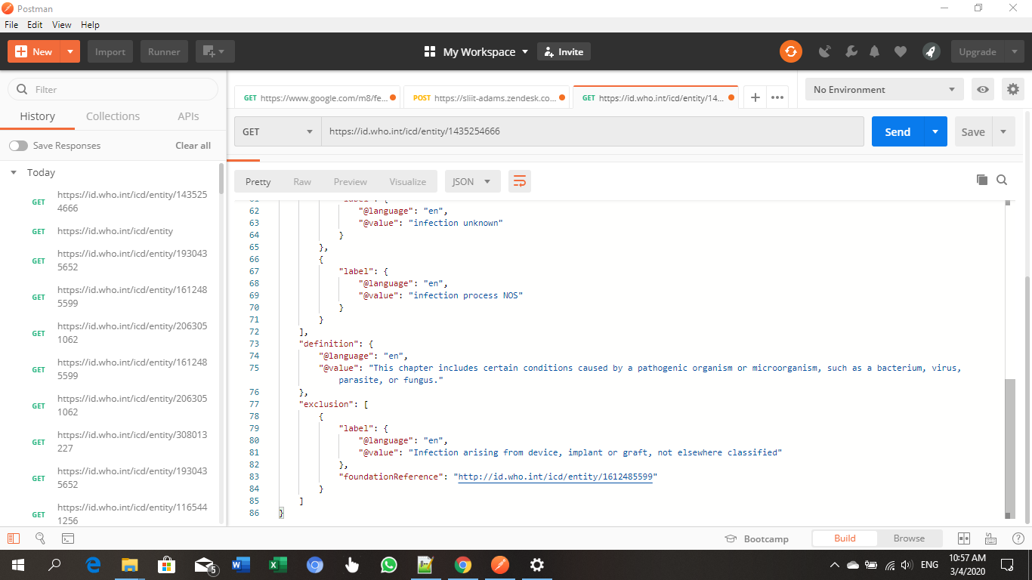

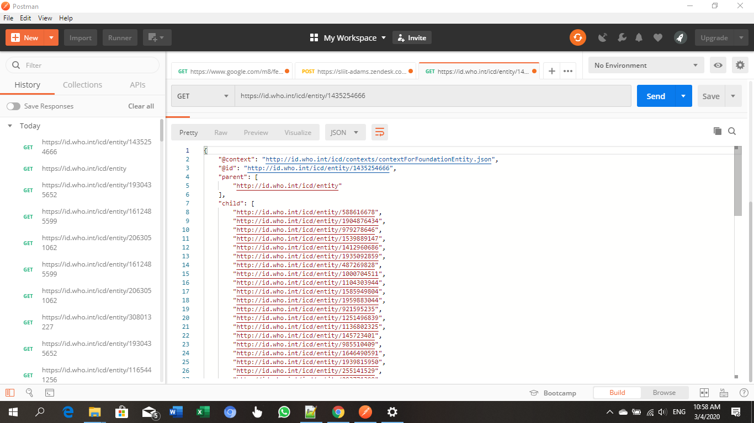

## **Facebook API**

The API accessed site:

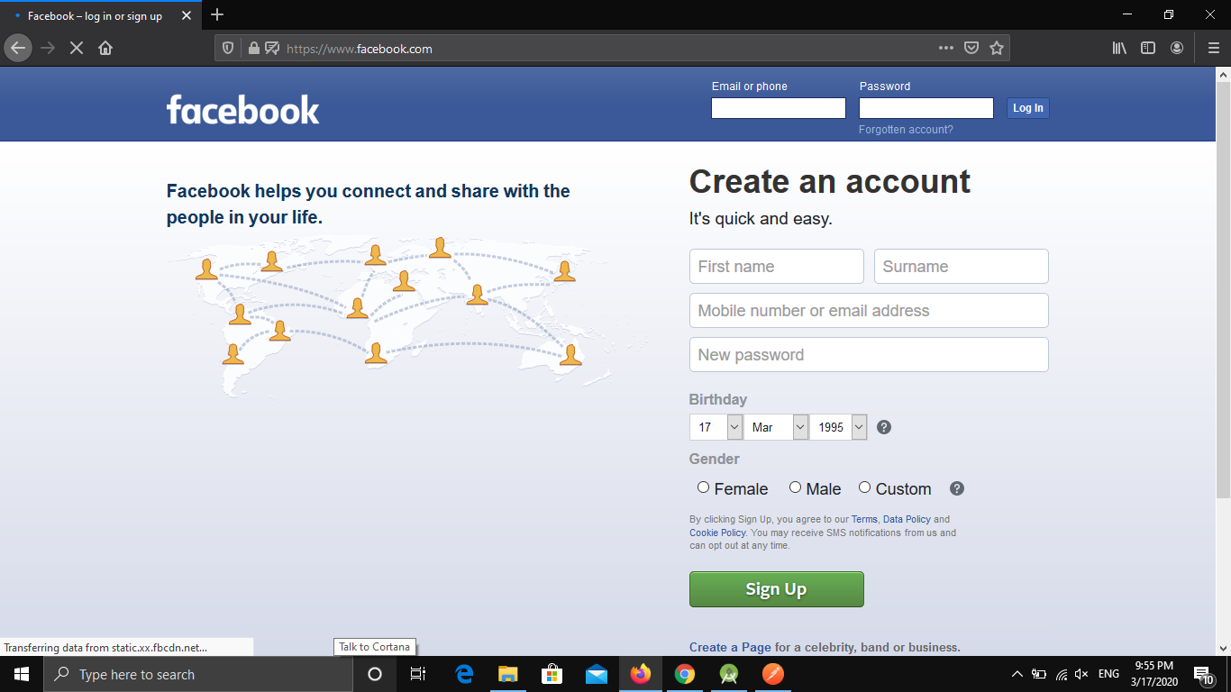

Request for a new access token:

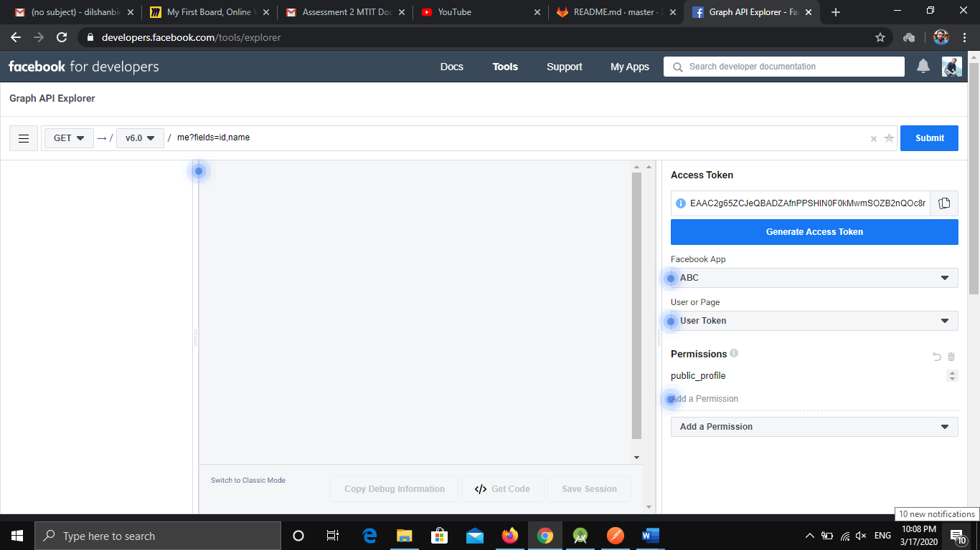

Configure the Authorization section in postman

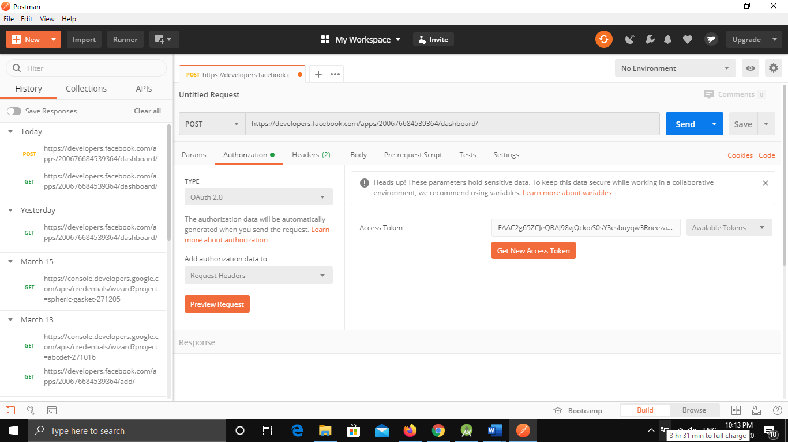

Configure the Header section by entering Keys and Values

Send the POST request and also can see the relevent response body with 200 OK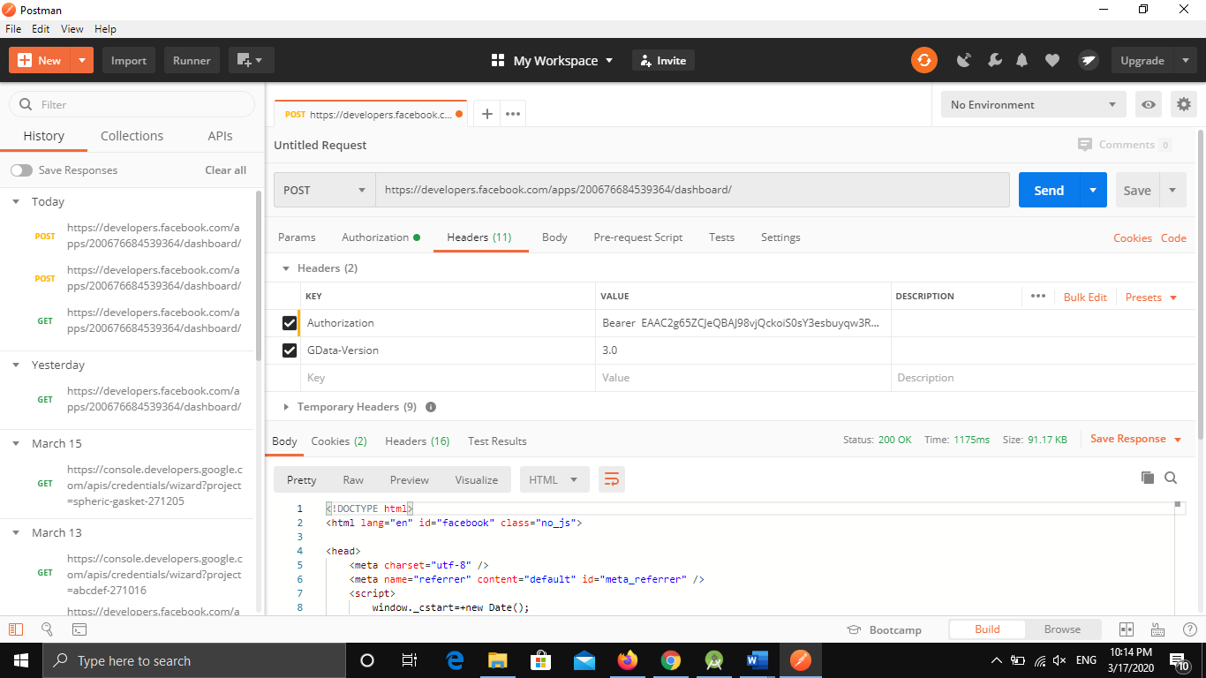

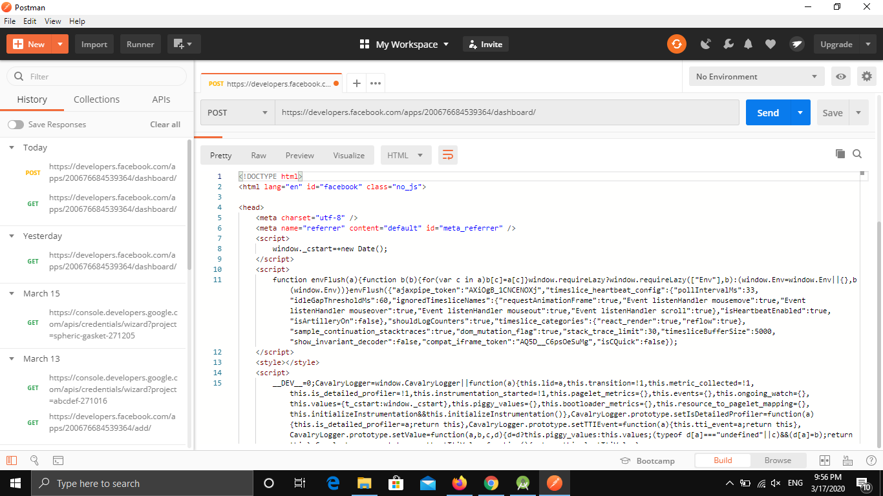

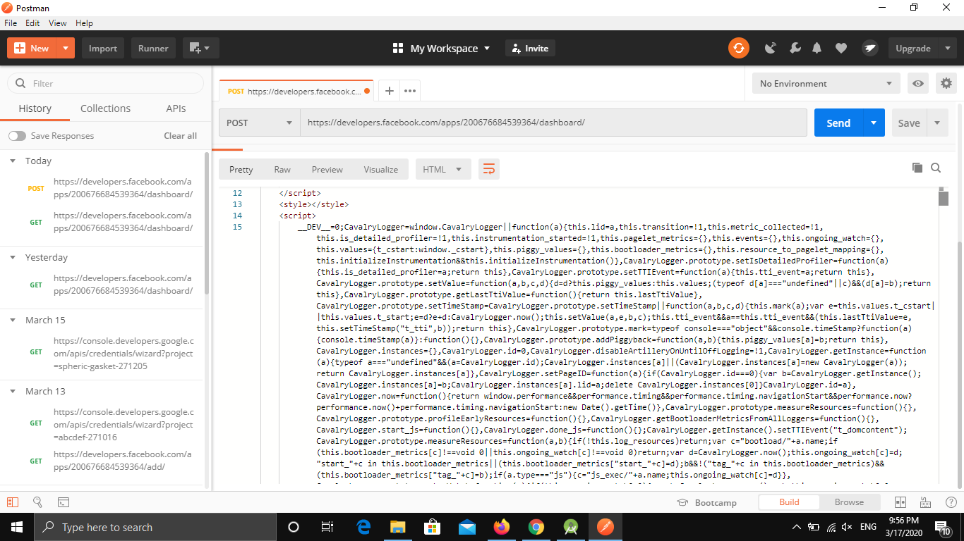

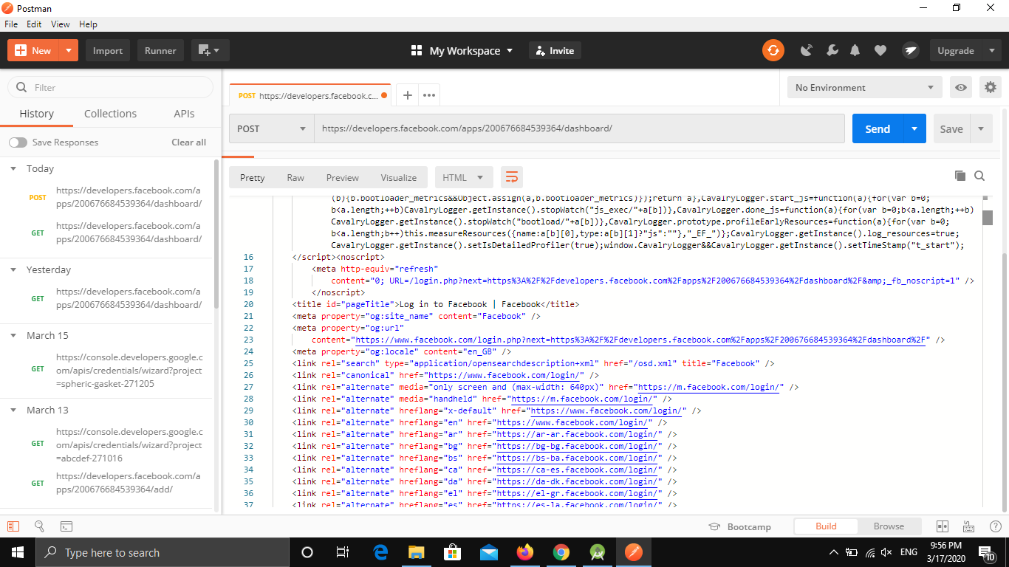

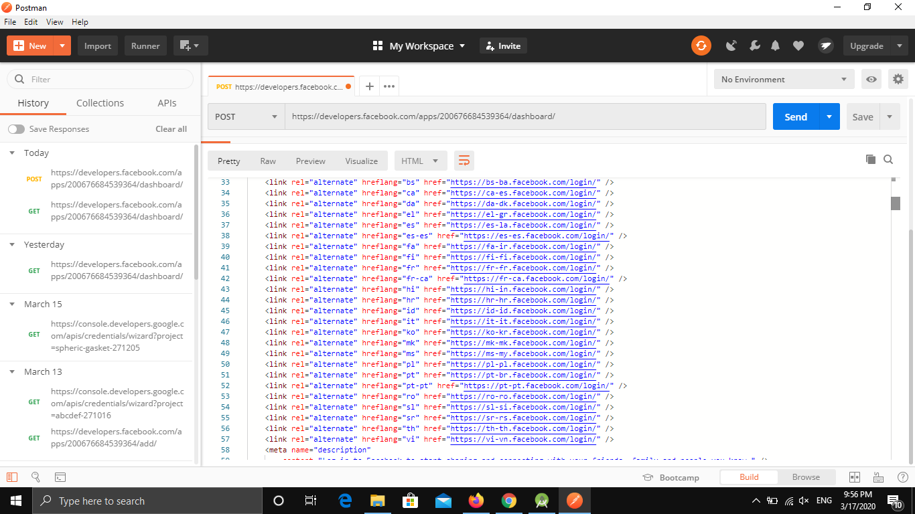

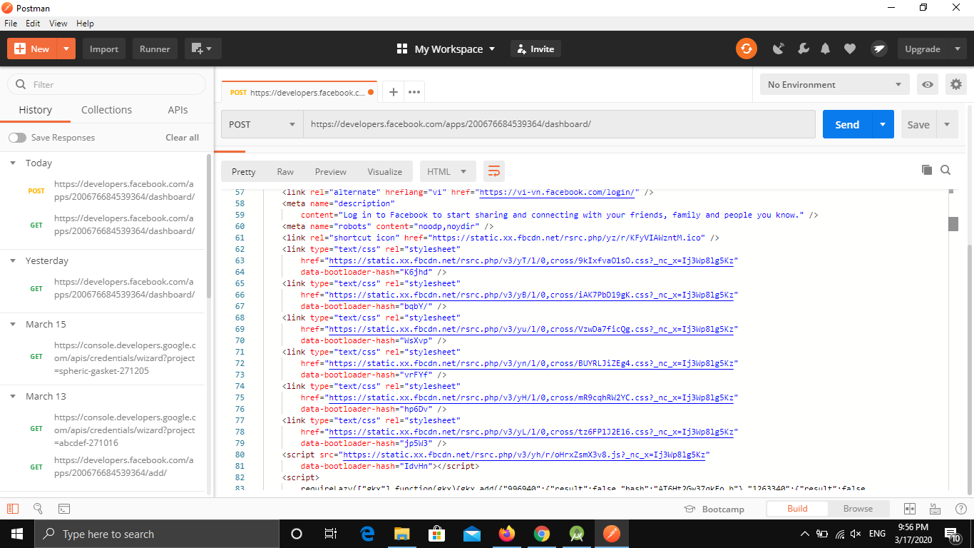

# **SOAP web service example in Eclipse**

Have to create the client project in Eclipse workspace, it will also launch client test JSP page as shown below.

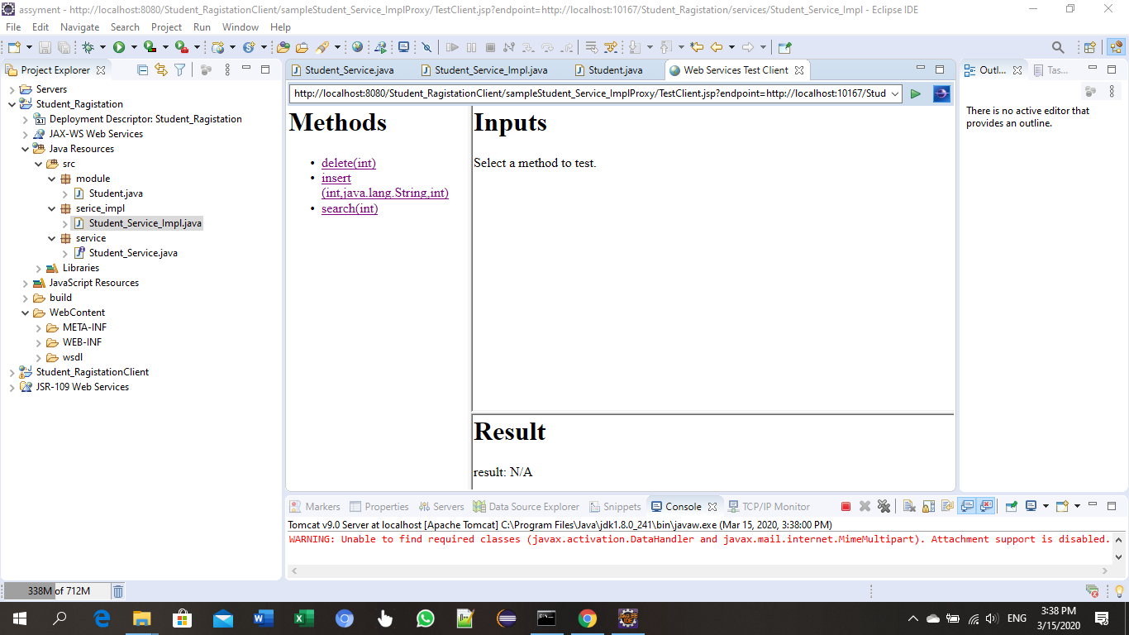

Create Student_Service_Impl.java class

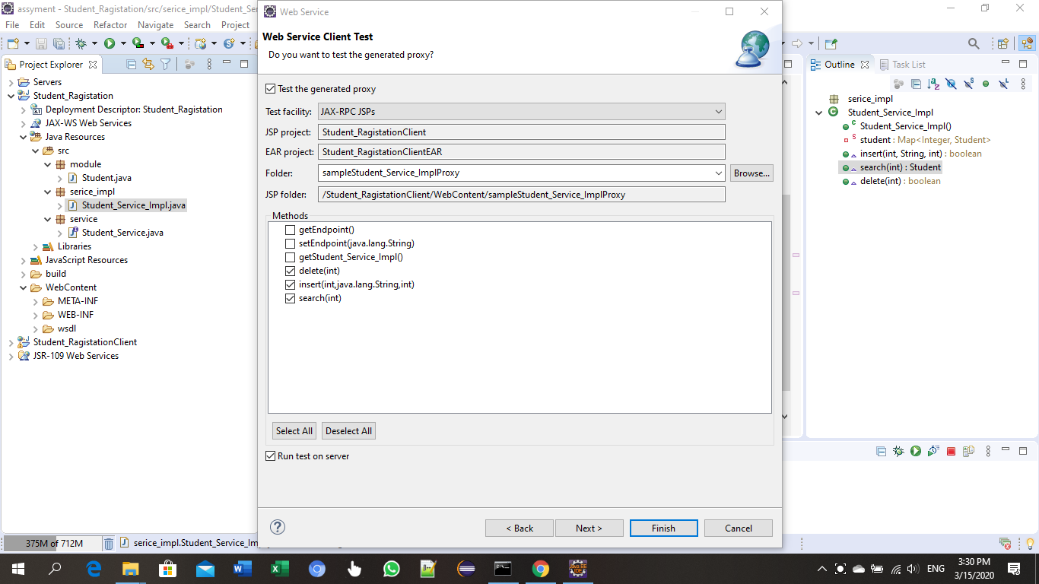

After run the project output will display as below. Initialy can be insert a record by filling some feilds

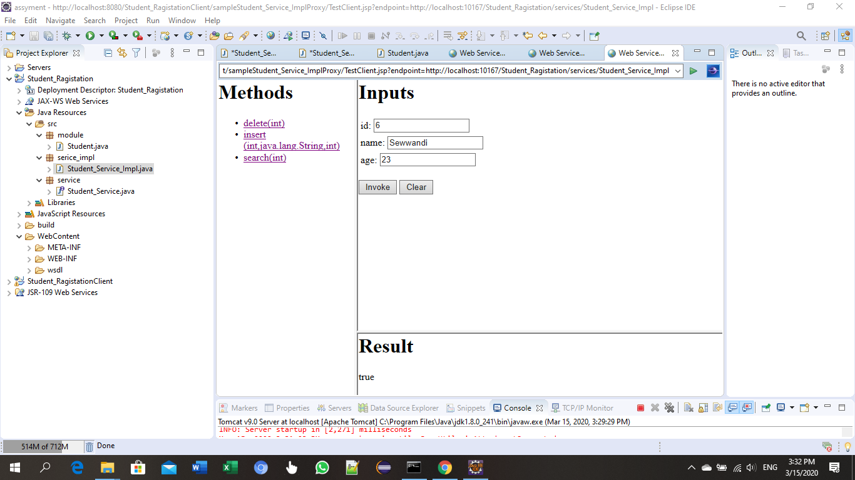

As the second operation can search for a record by giving the “id”

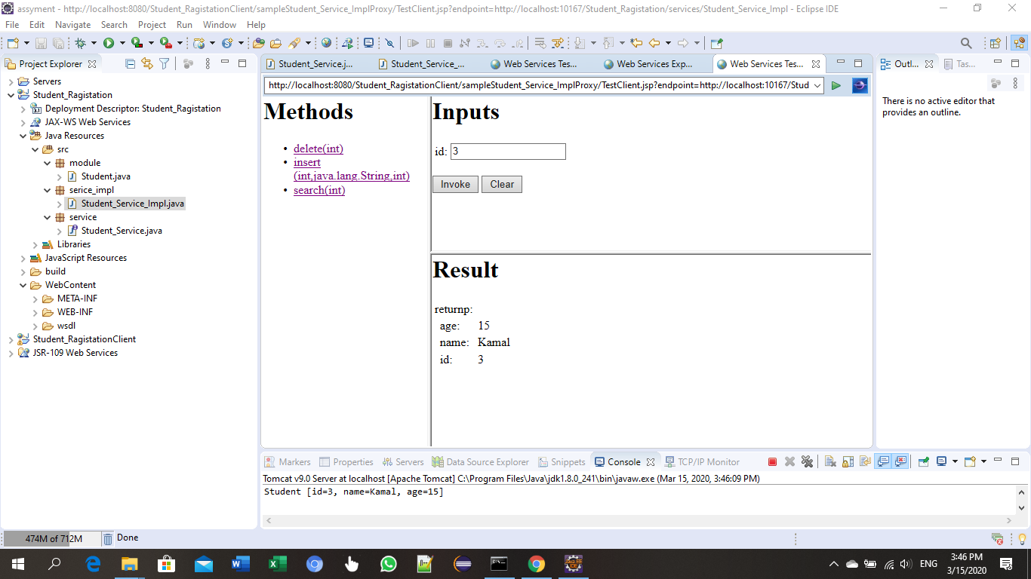

As the Thired operation can get All Student

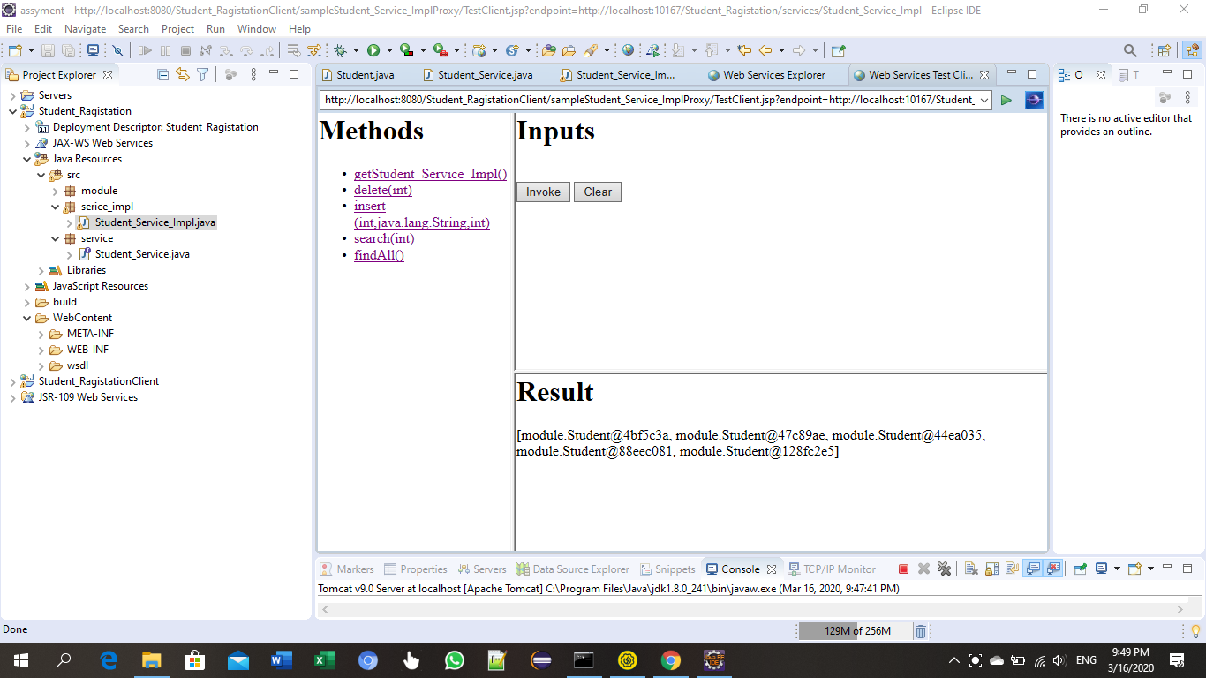

Last operation is delete a record by searching from the “id”

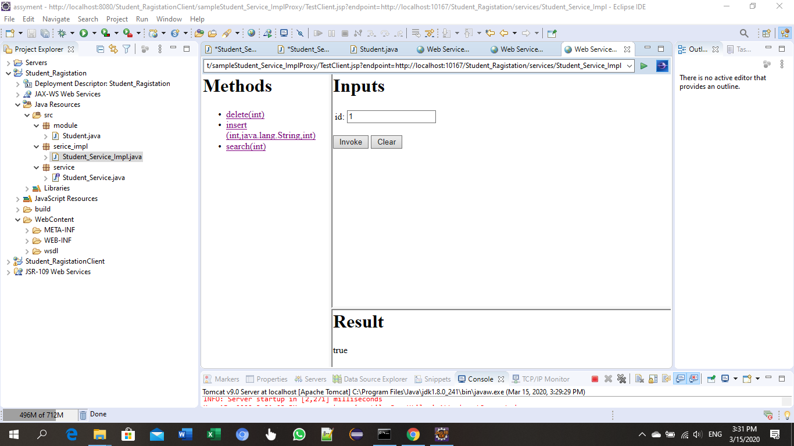

# **Access 3rd party web service through WSO2 ESB and going to test the service through ESB**

In here we are creating Student_Service_ImplService WSDL Service in WSO2

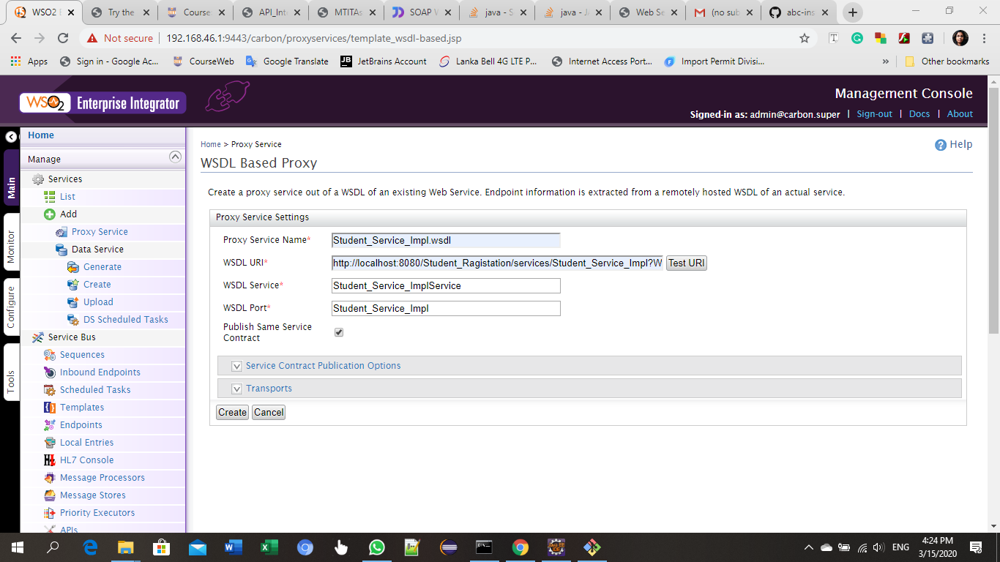

Successful status after the creation of WSO2 – WSDL based Proxy

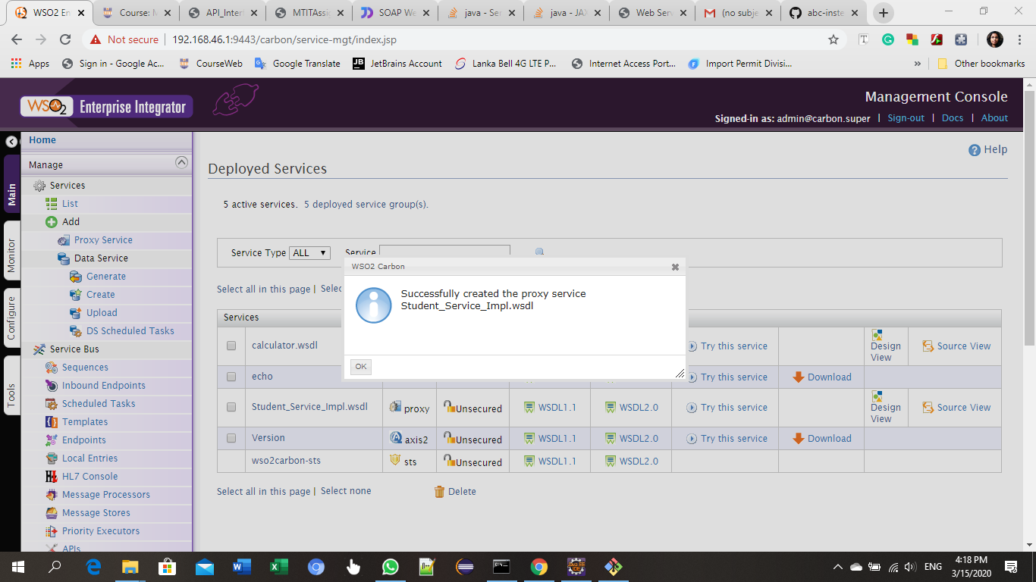

Can see the Student_Service_Impl.wsdl proxy service

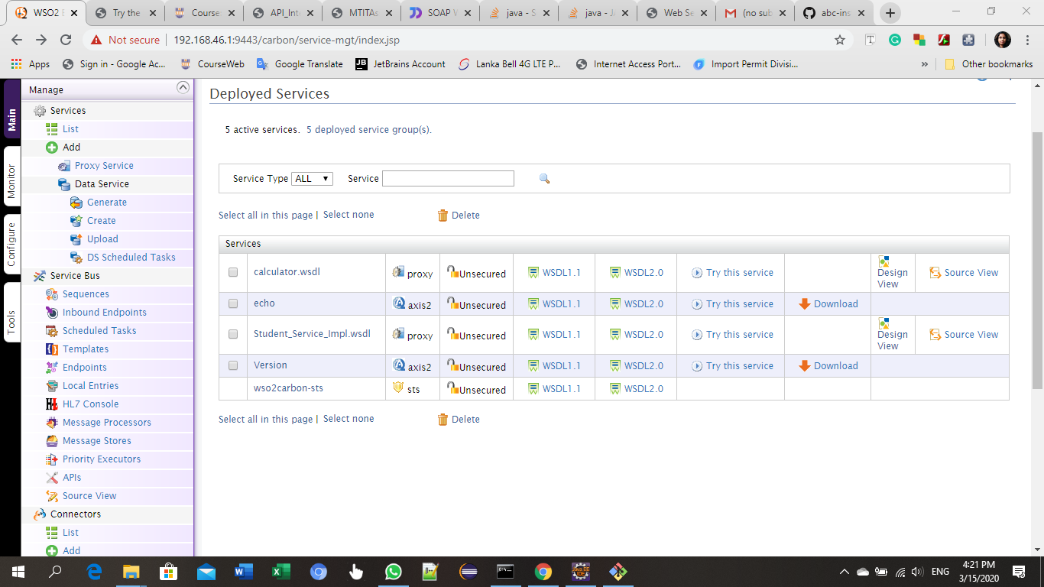

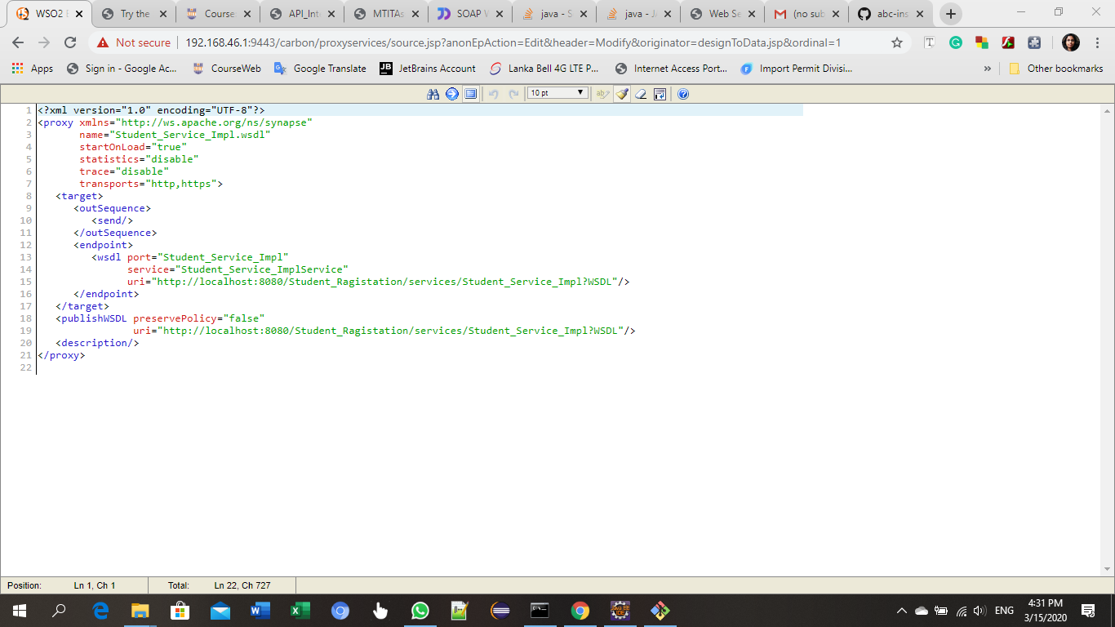

By clicking “Try this service” in Student_Service_Impl.wsdl Service, web service will open in web browser. Display as below

According to the Insert operation. Give the relevant data to implement the insert operation

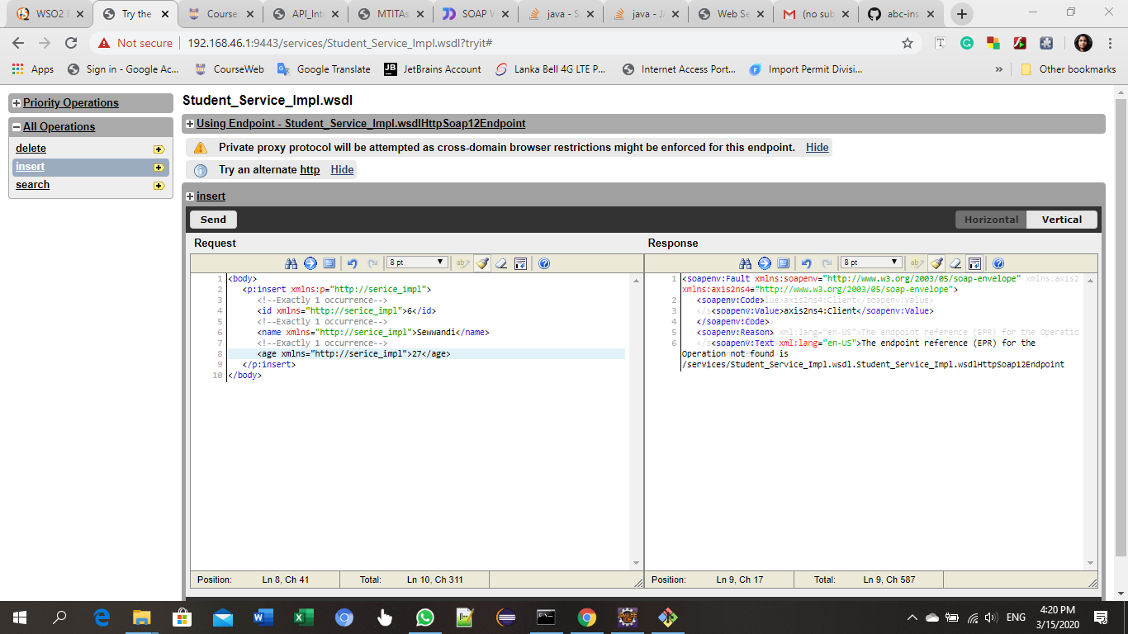

In search operation can search a record by giving “id”

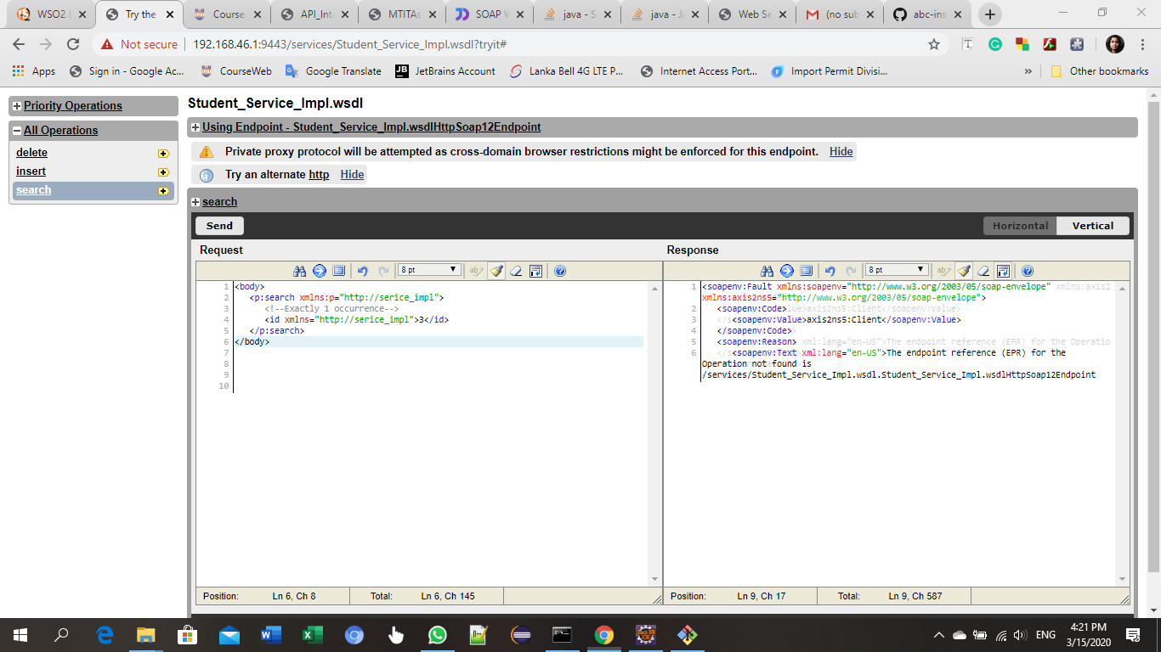

Delete operation. Give the relevant “id” to implement the delete operation

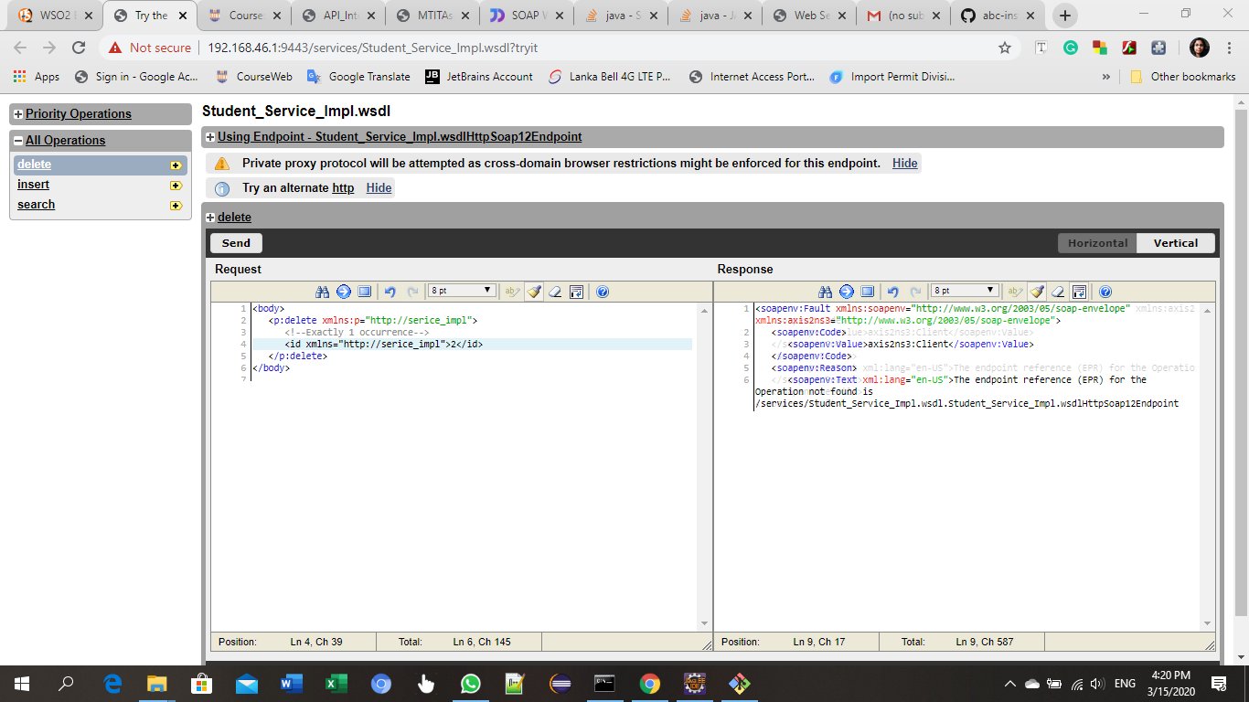

FindAll operation

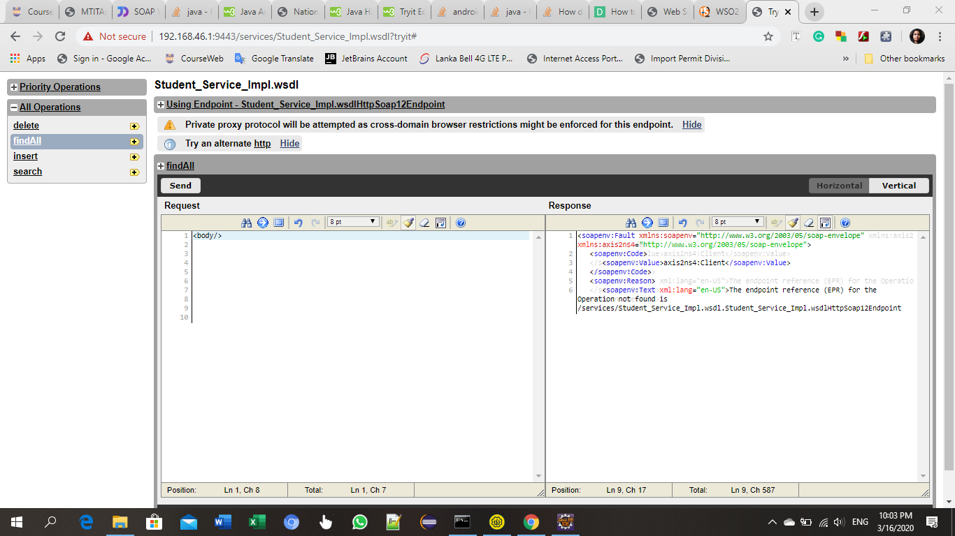

# **SOAP UI and service implementation**

SOAP UI and send requests to created web service via ESB

In SOAP UI have to create a SOAP project

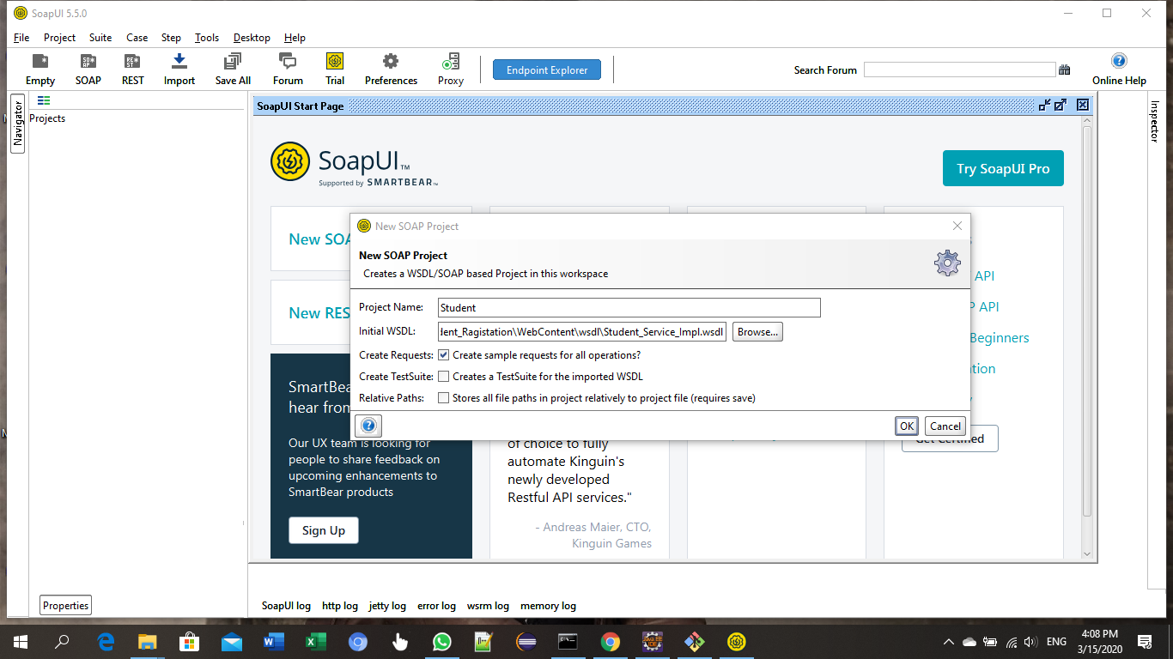

SOAP UI will display as below after crating the project

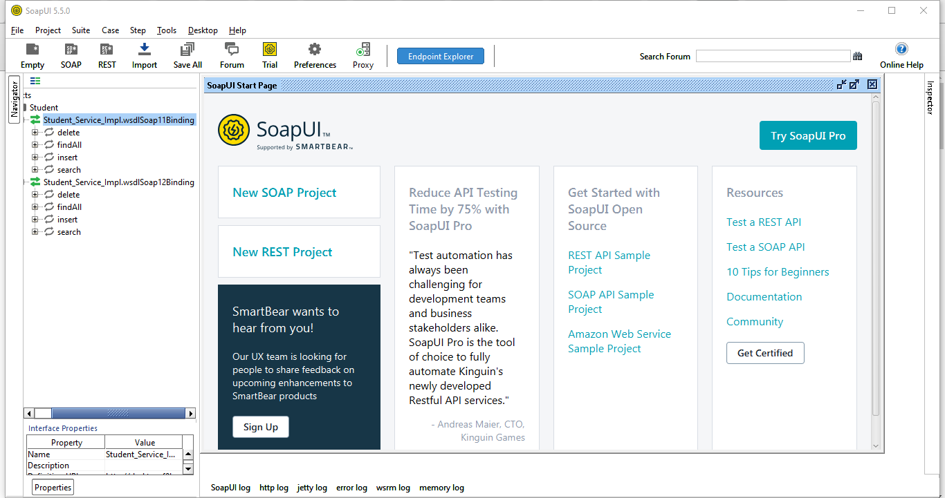

Delete:

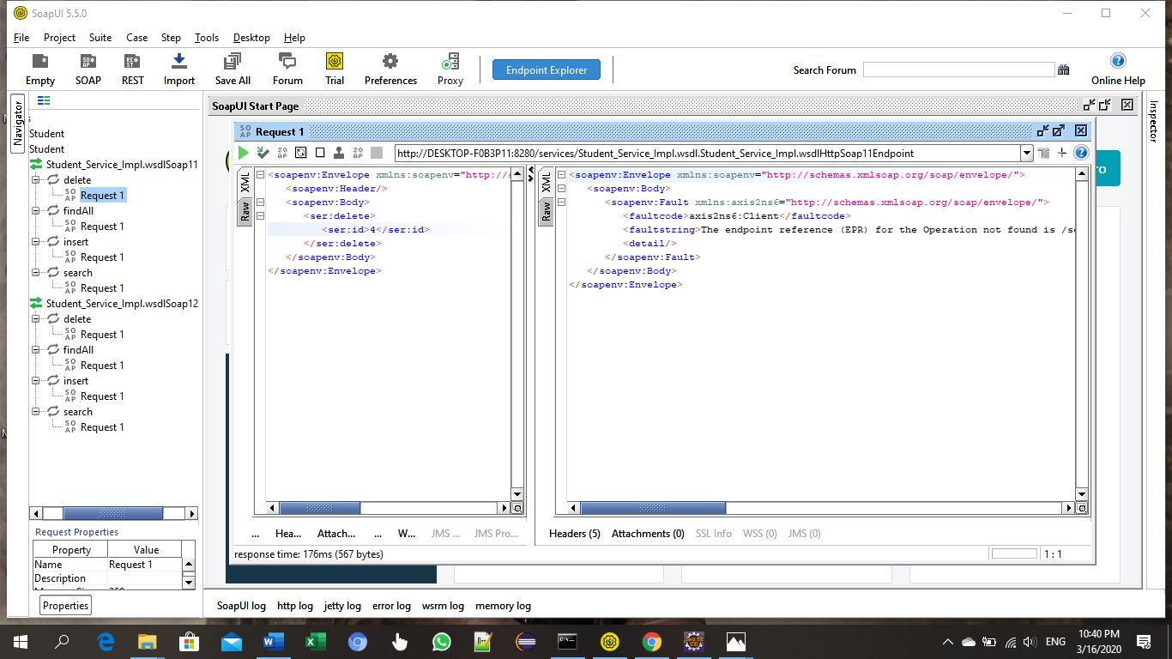

FindAll:

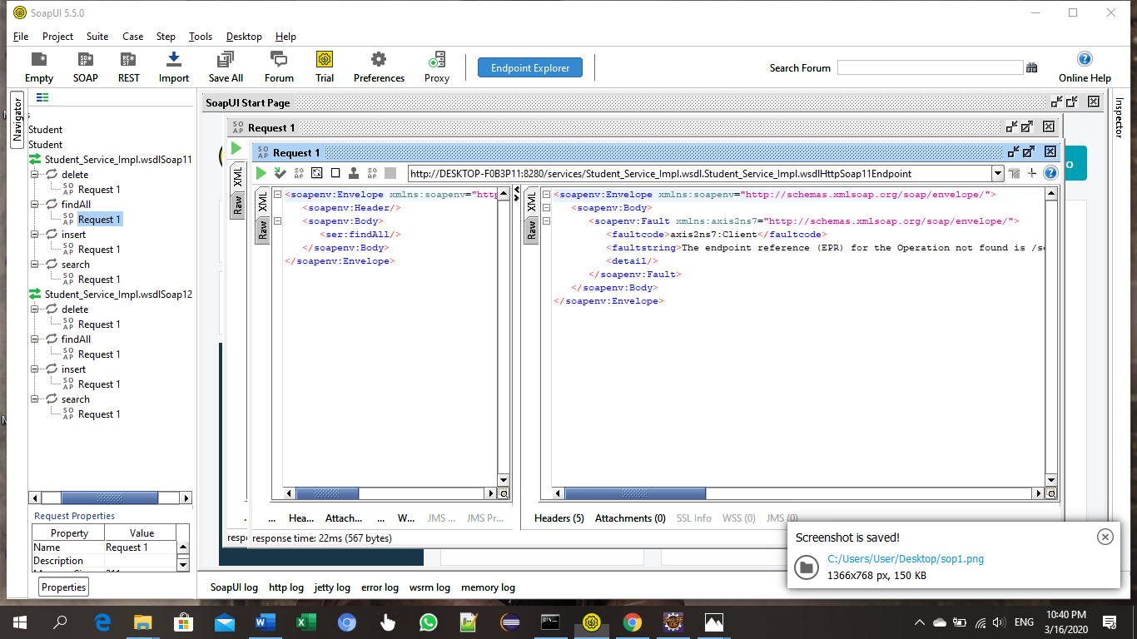

Search:

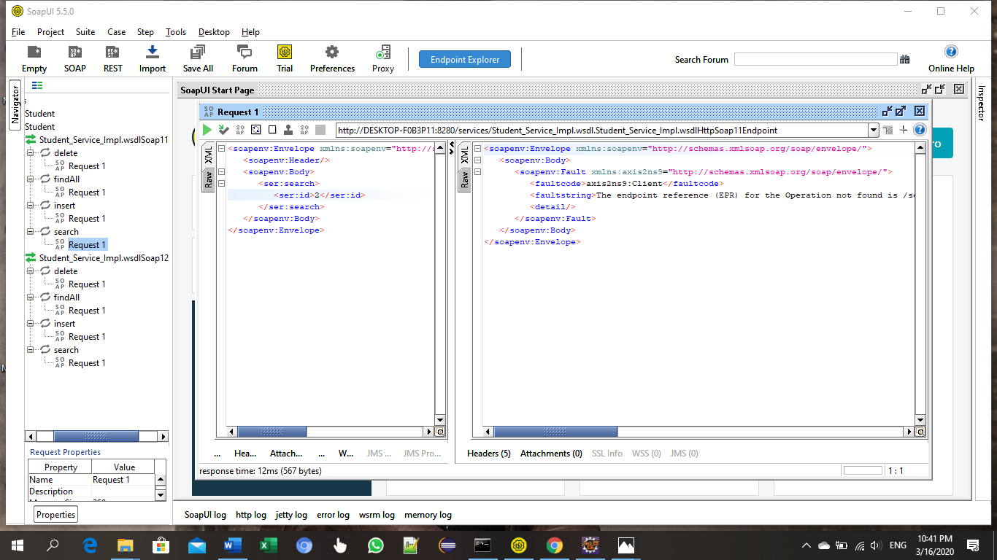

Insert:

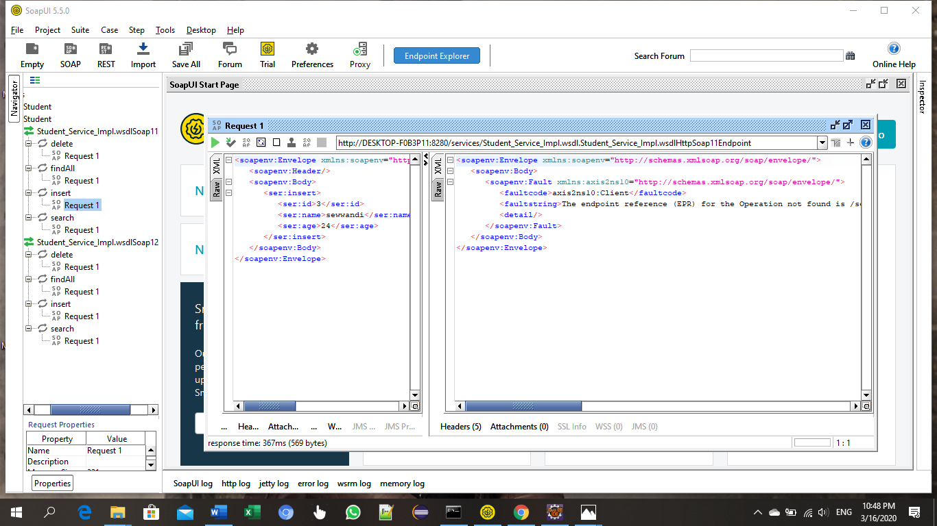

# **WSDL services will display as below**

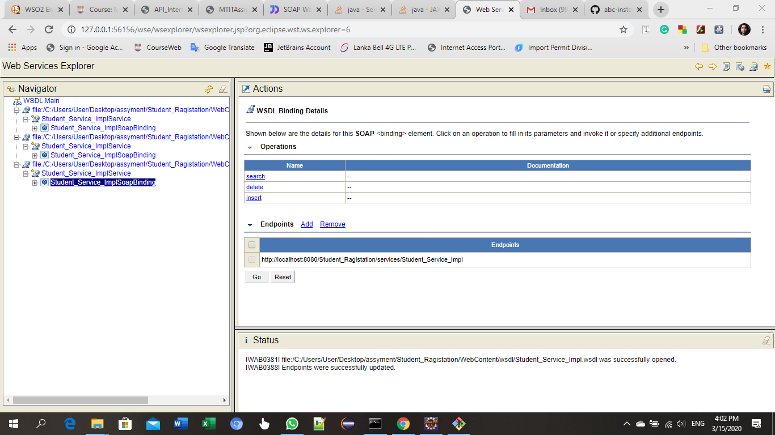

Insert :

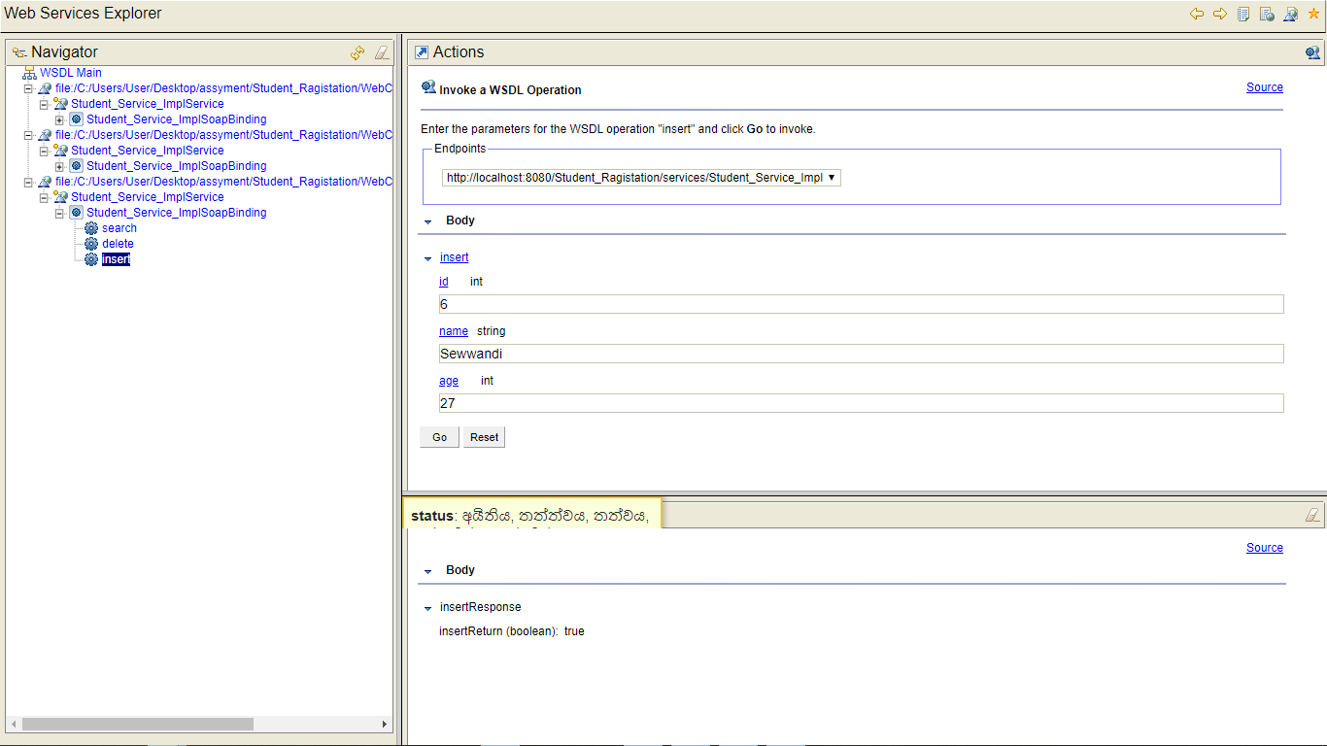

Search:

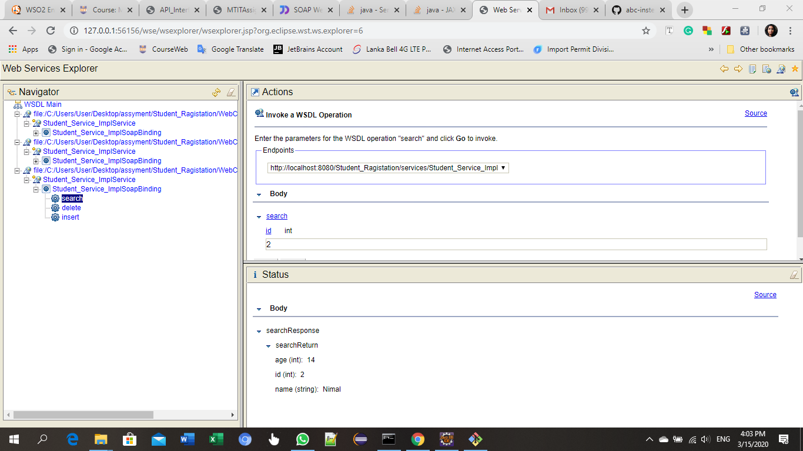

Delete:

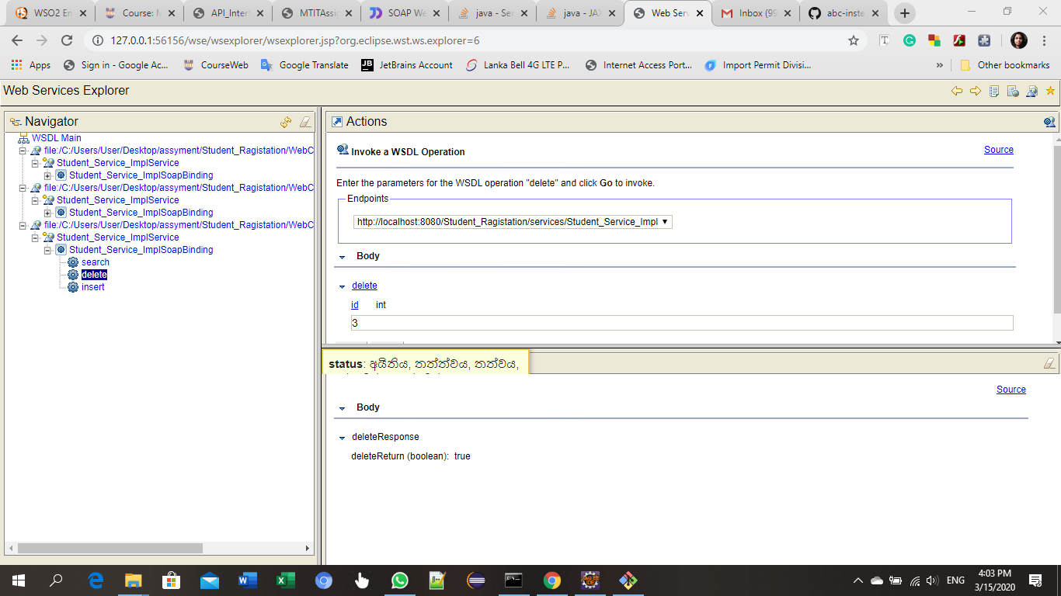

FindAll :

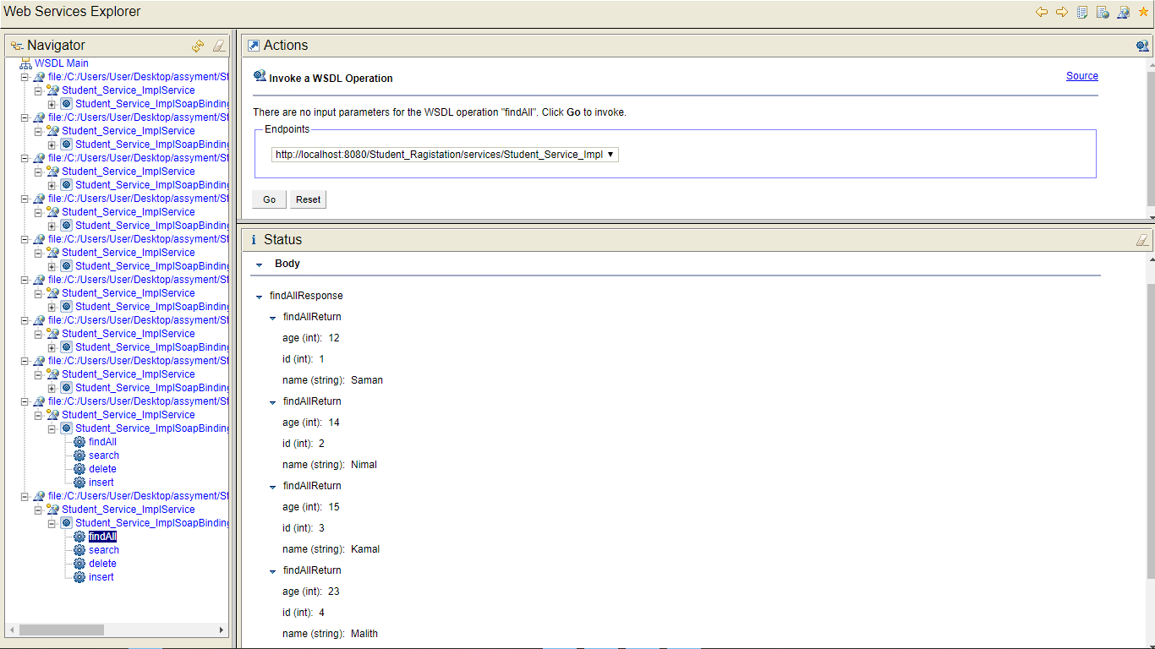

# **SOAP UI project create with Student_Service_Impl.wsdl**

Insert Operation in SOAP UI

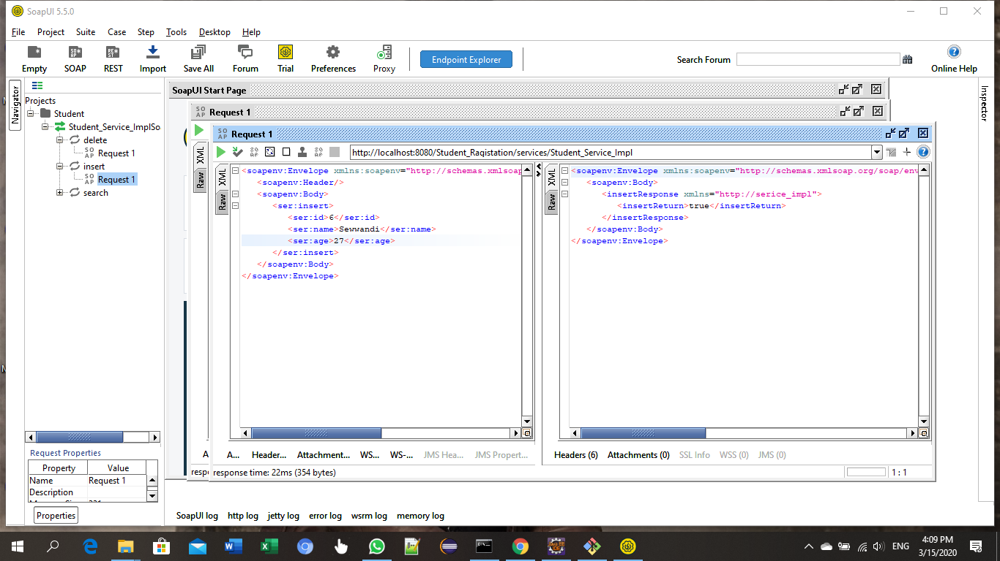

Search Operation in SOAP UI

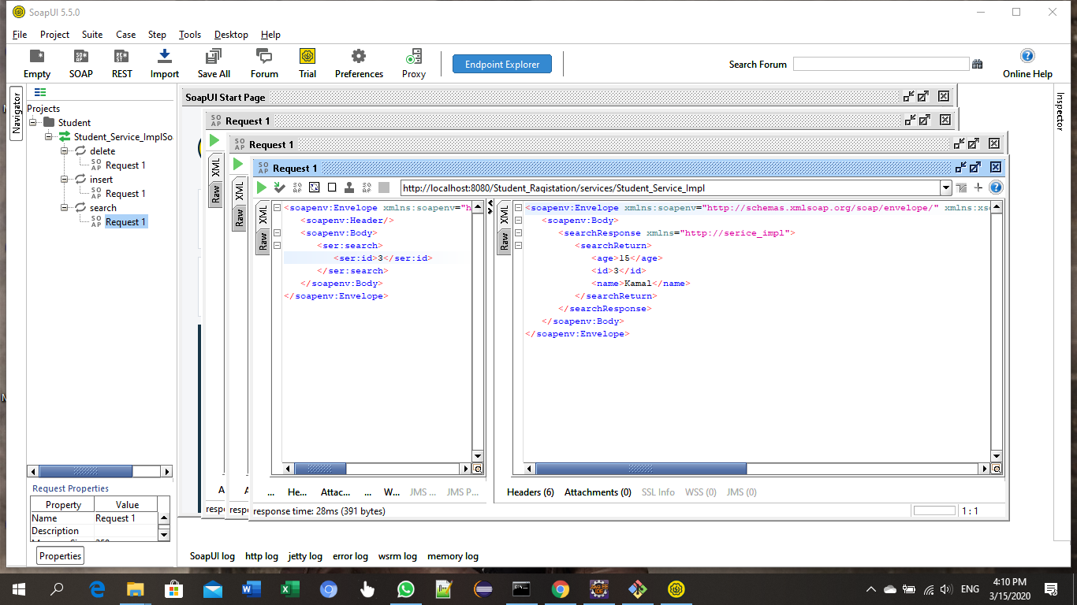

Delete Operation in SOAP UI

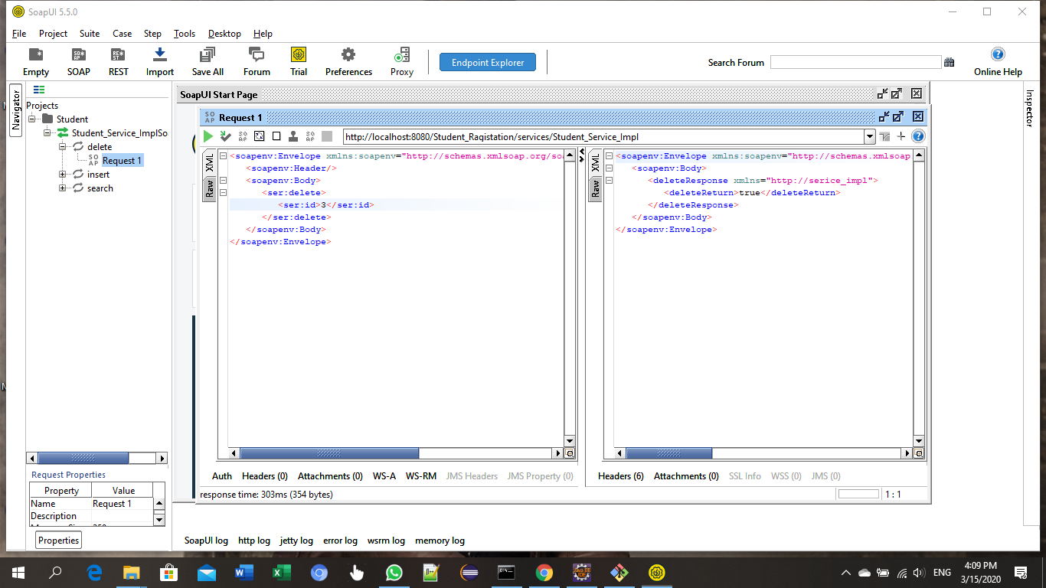

FinAll Operation in SOAP UI

